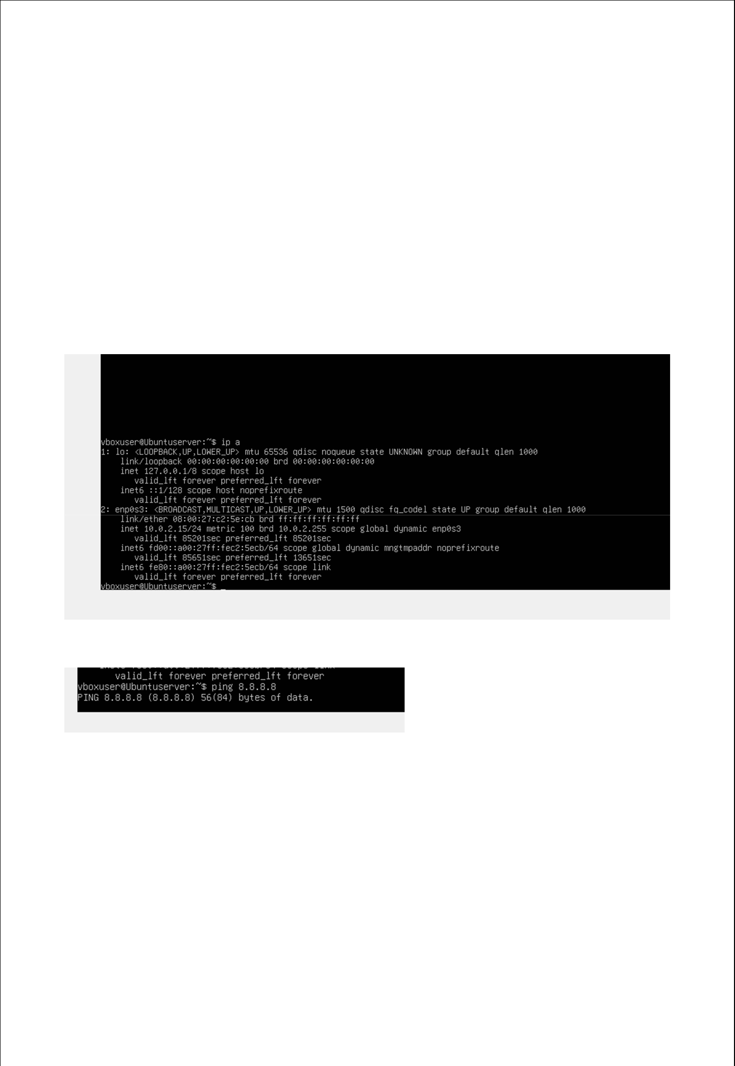
Week 4

Ini al System Configura on & Security Implementa on

Objective:

The main objective of this phase is to do performance metrics that were monitored included CPU, memory, disc, and uptime.

SSH INSTALLATION AND CONFIGURATION:

Below I have installed openSSH server and checked its status which is active.
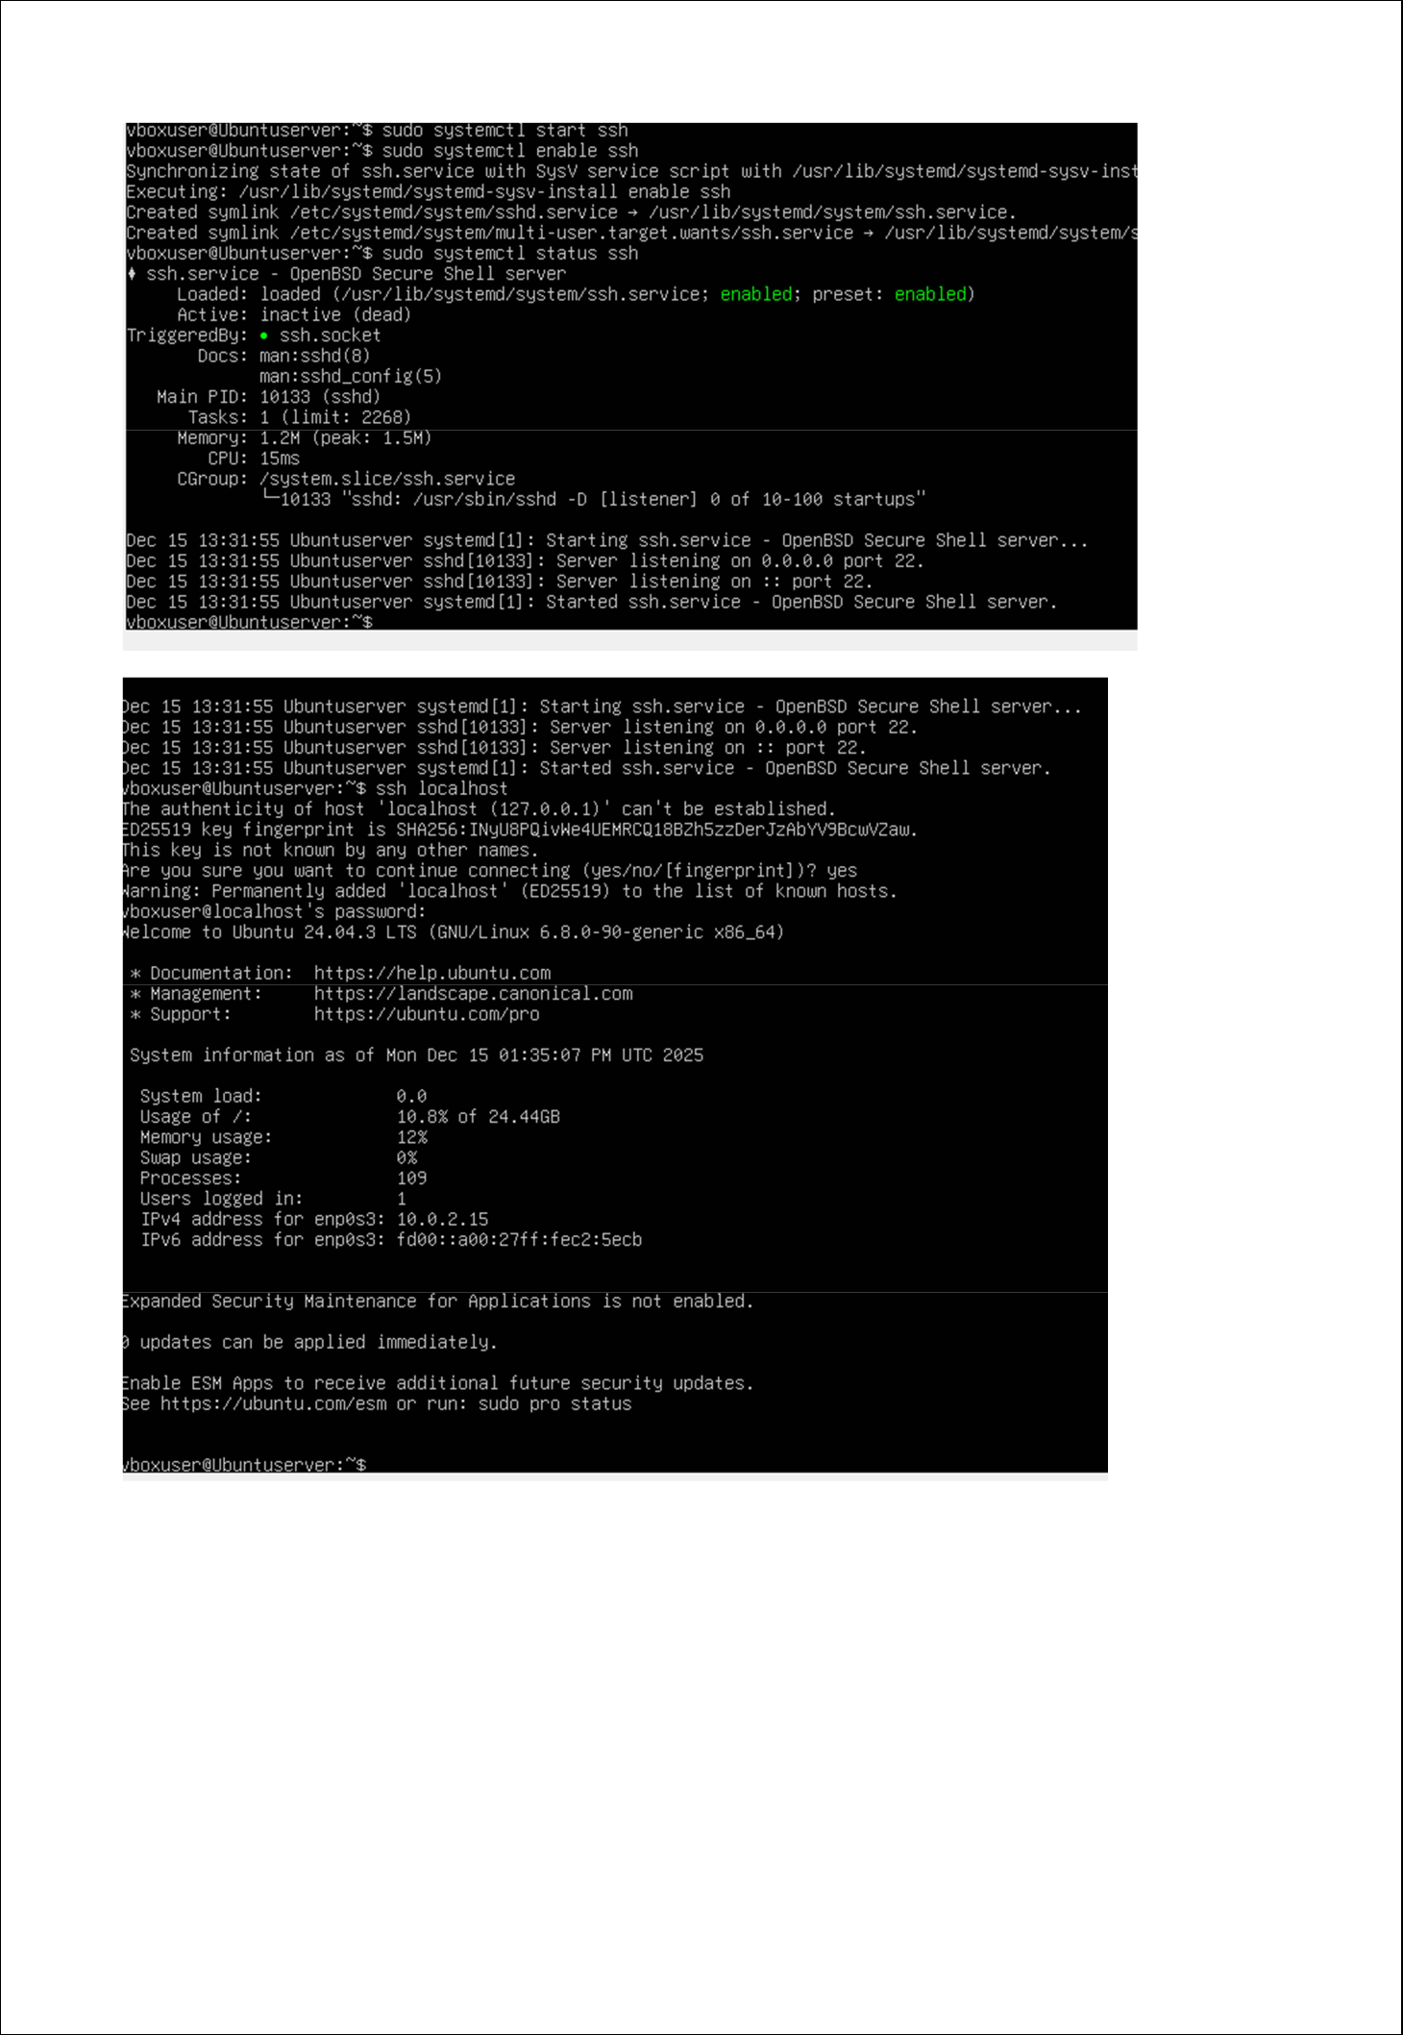
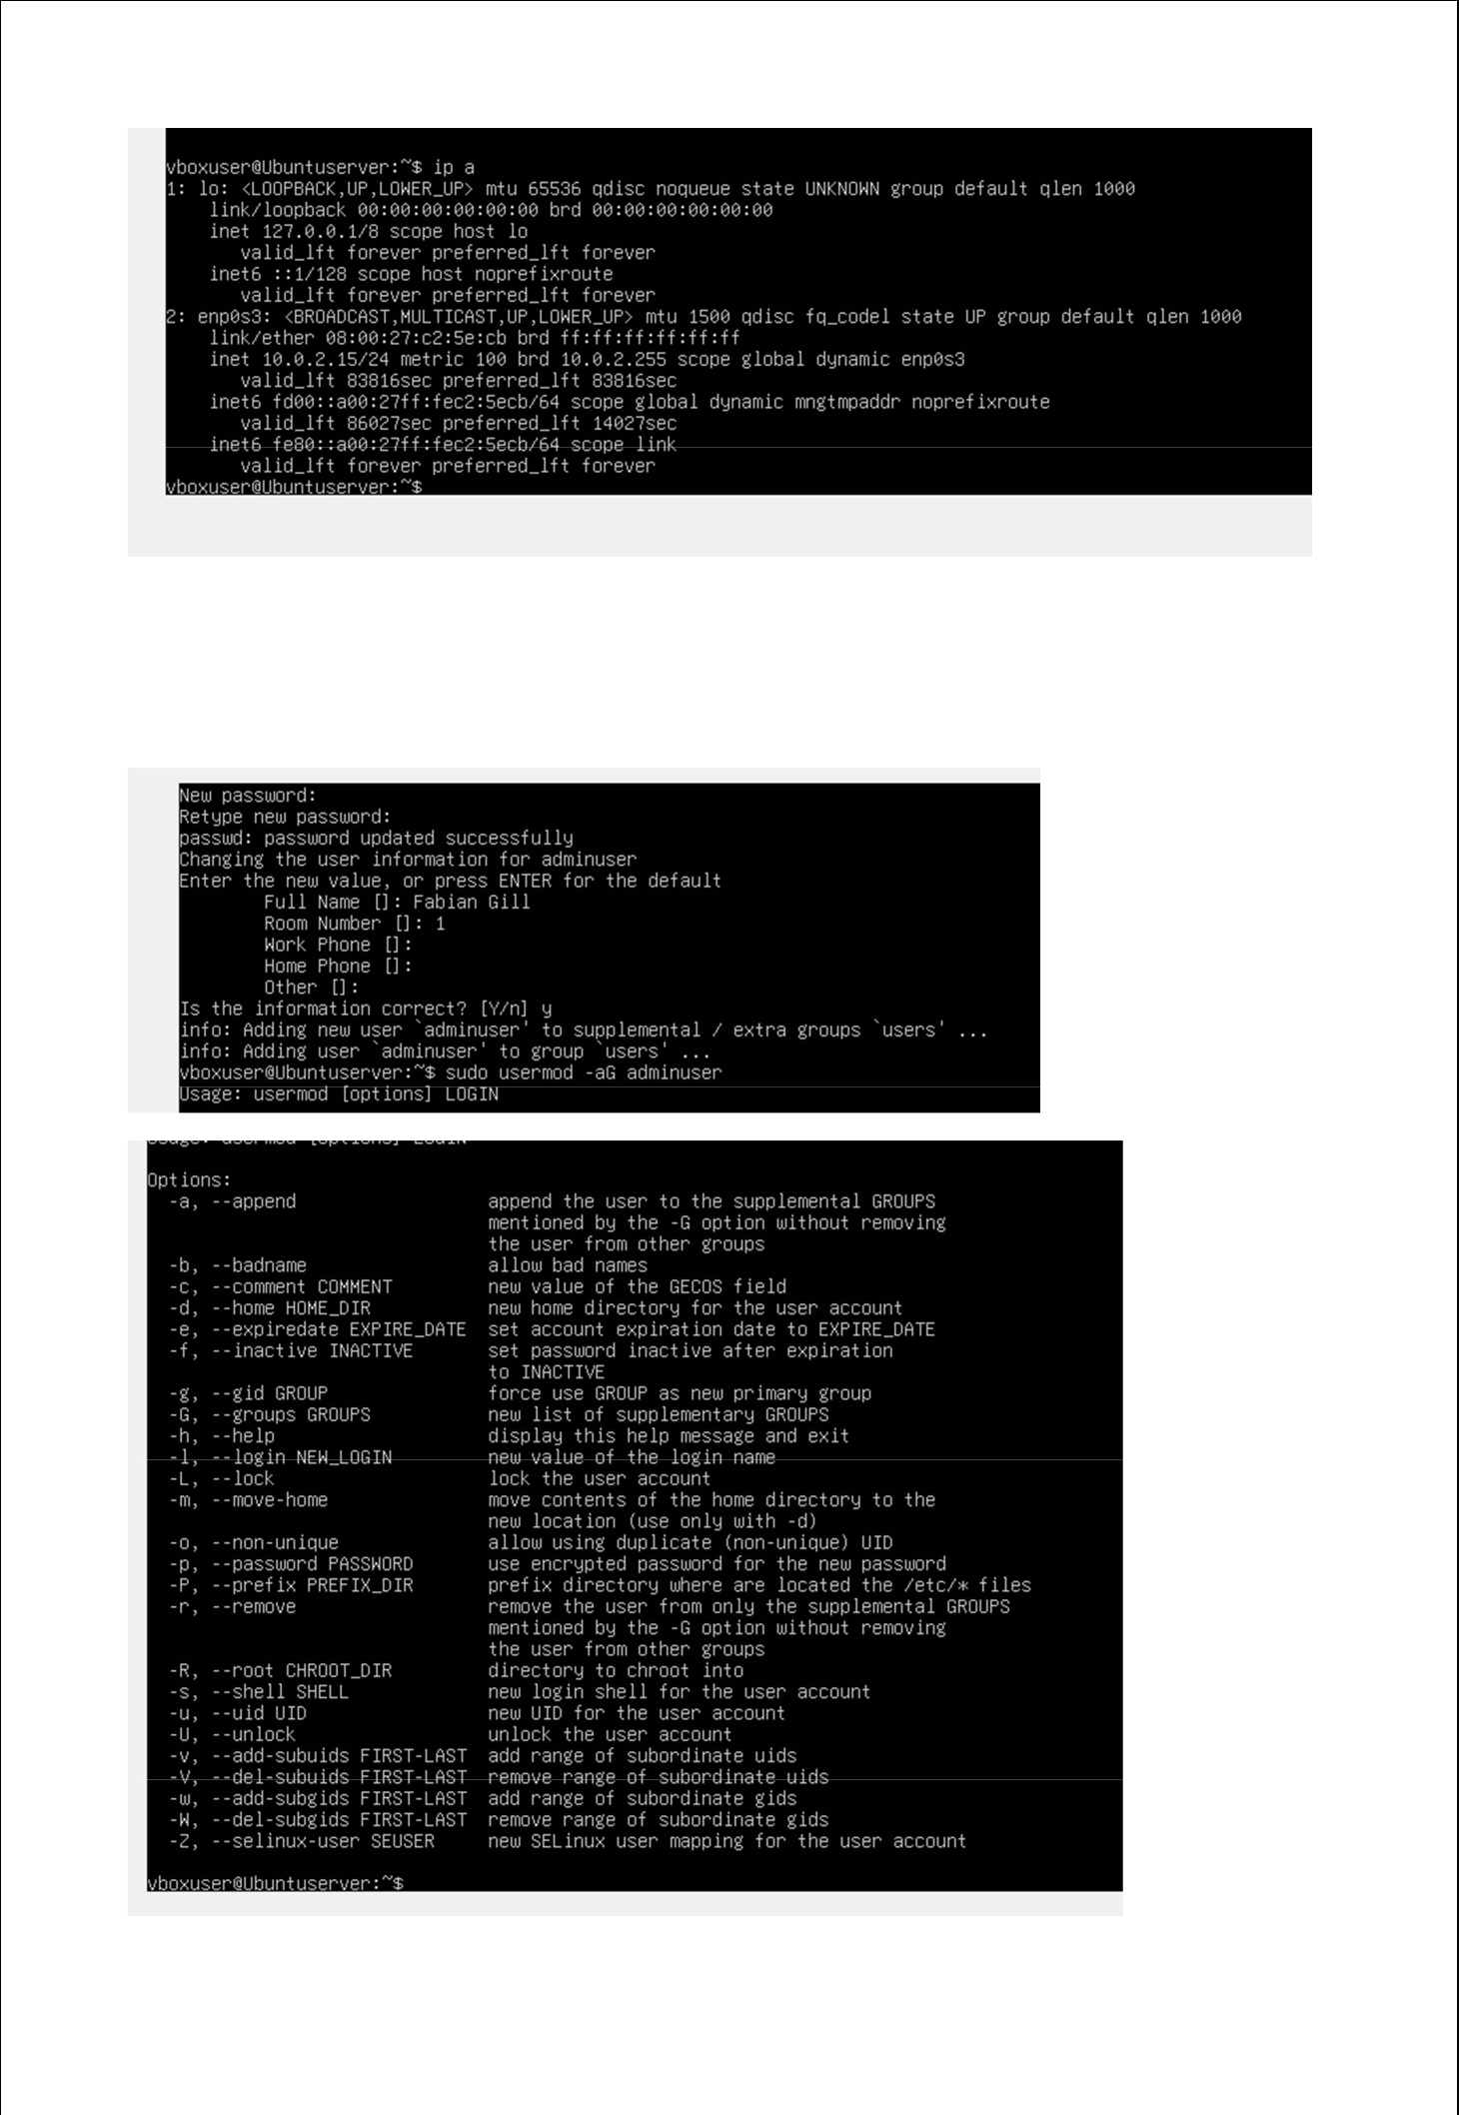

User Management:

Sudo privileges were granted to a newly created non-root administrative user.
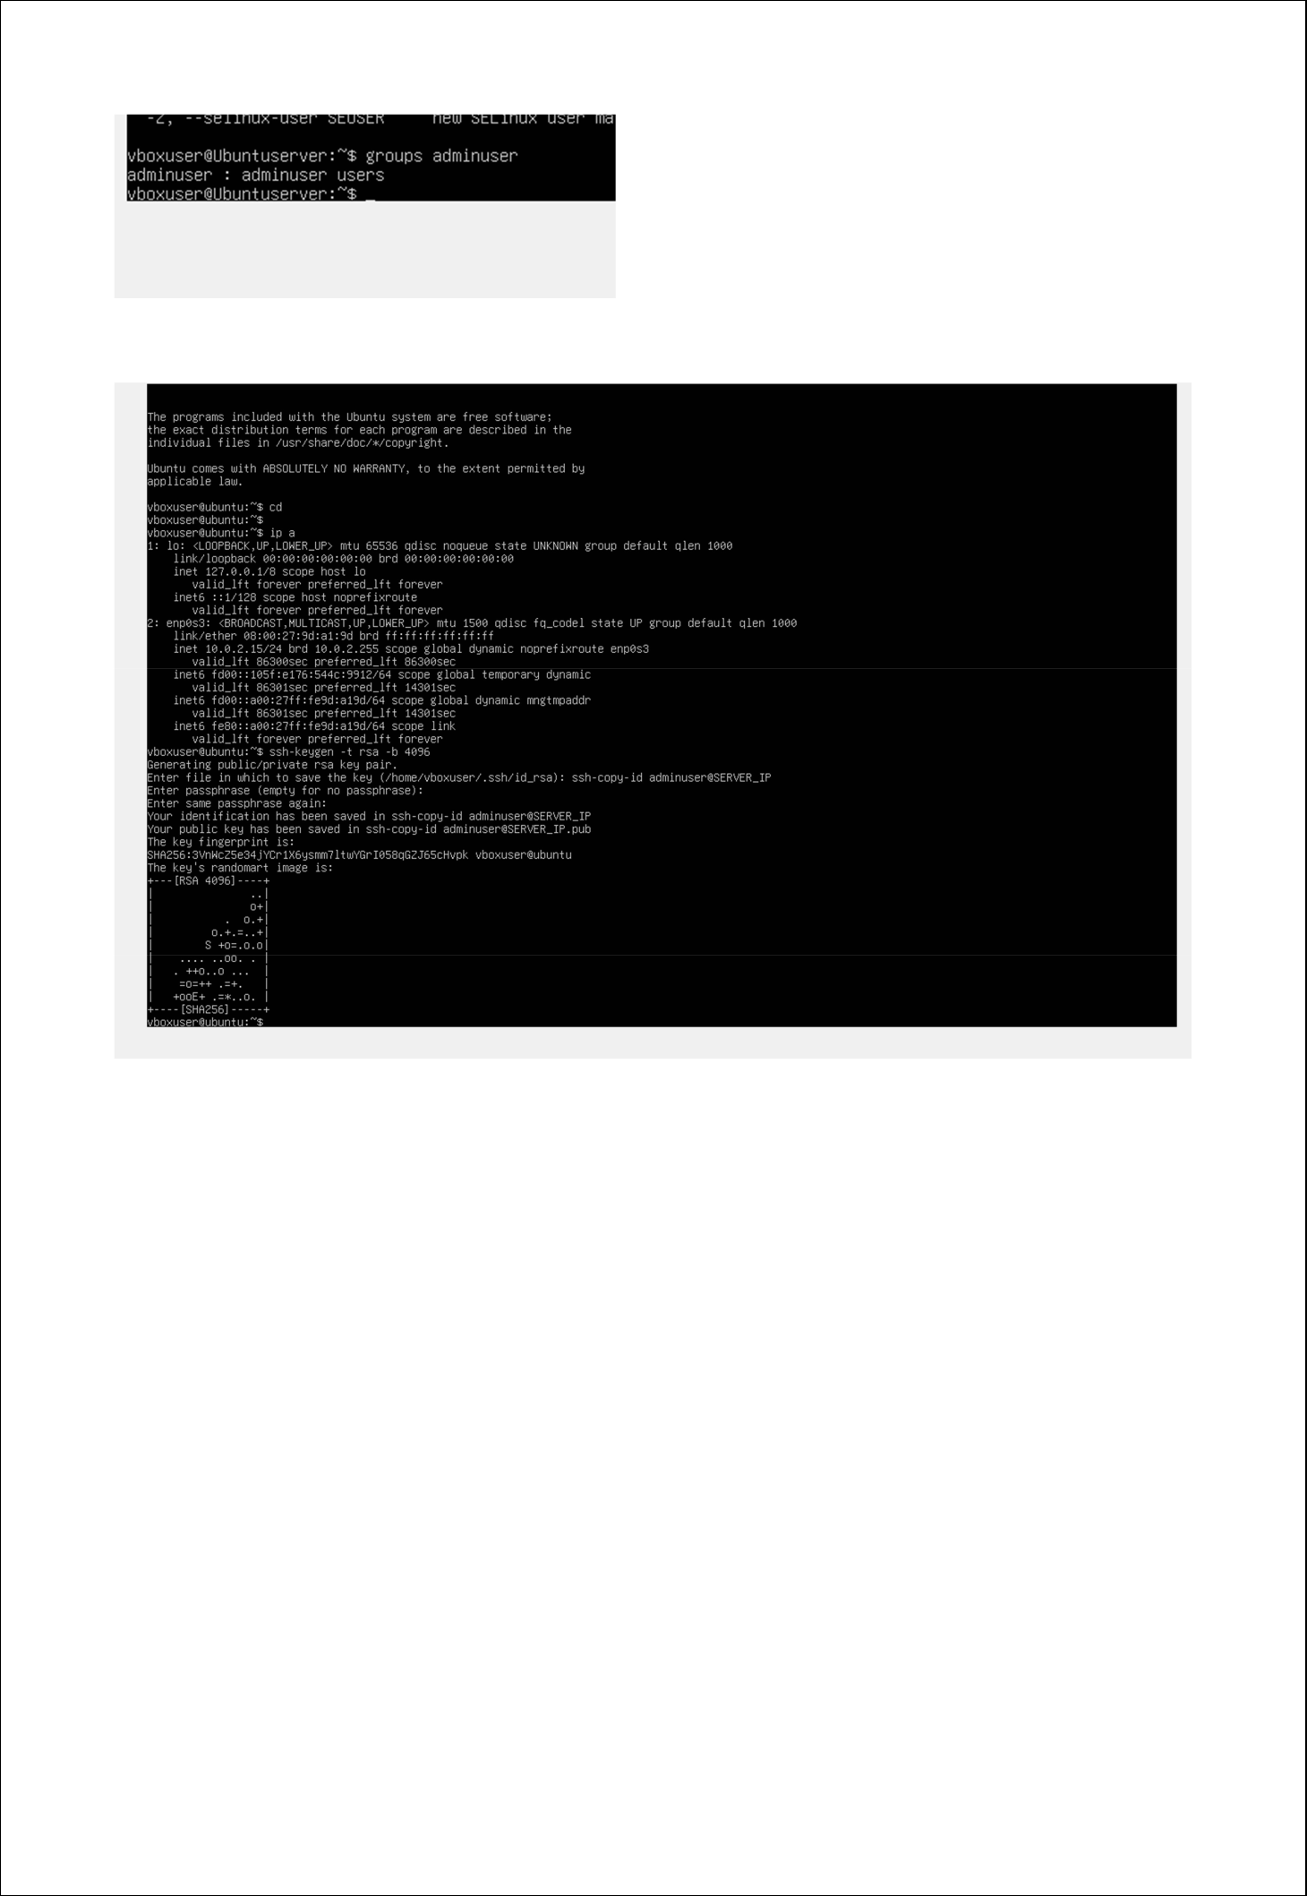
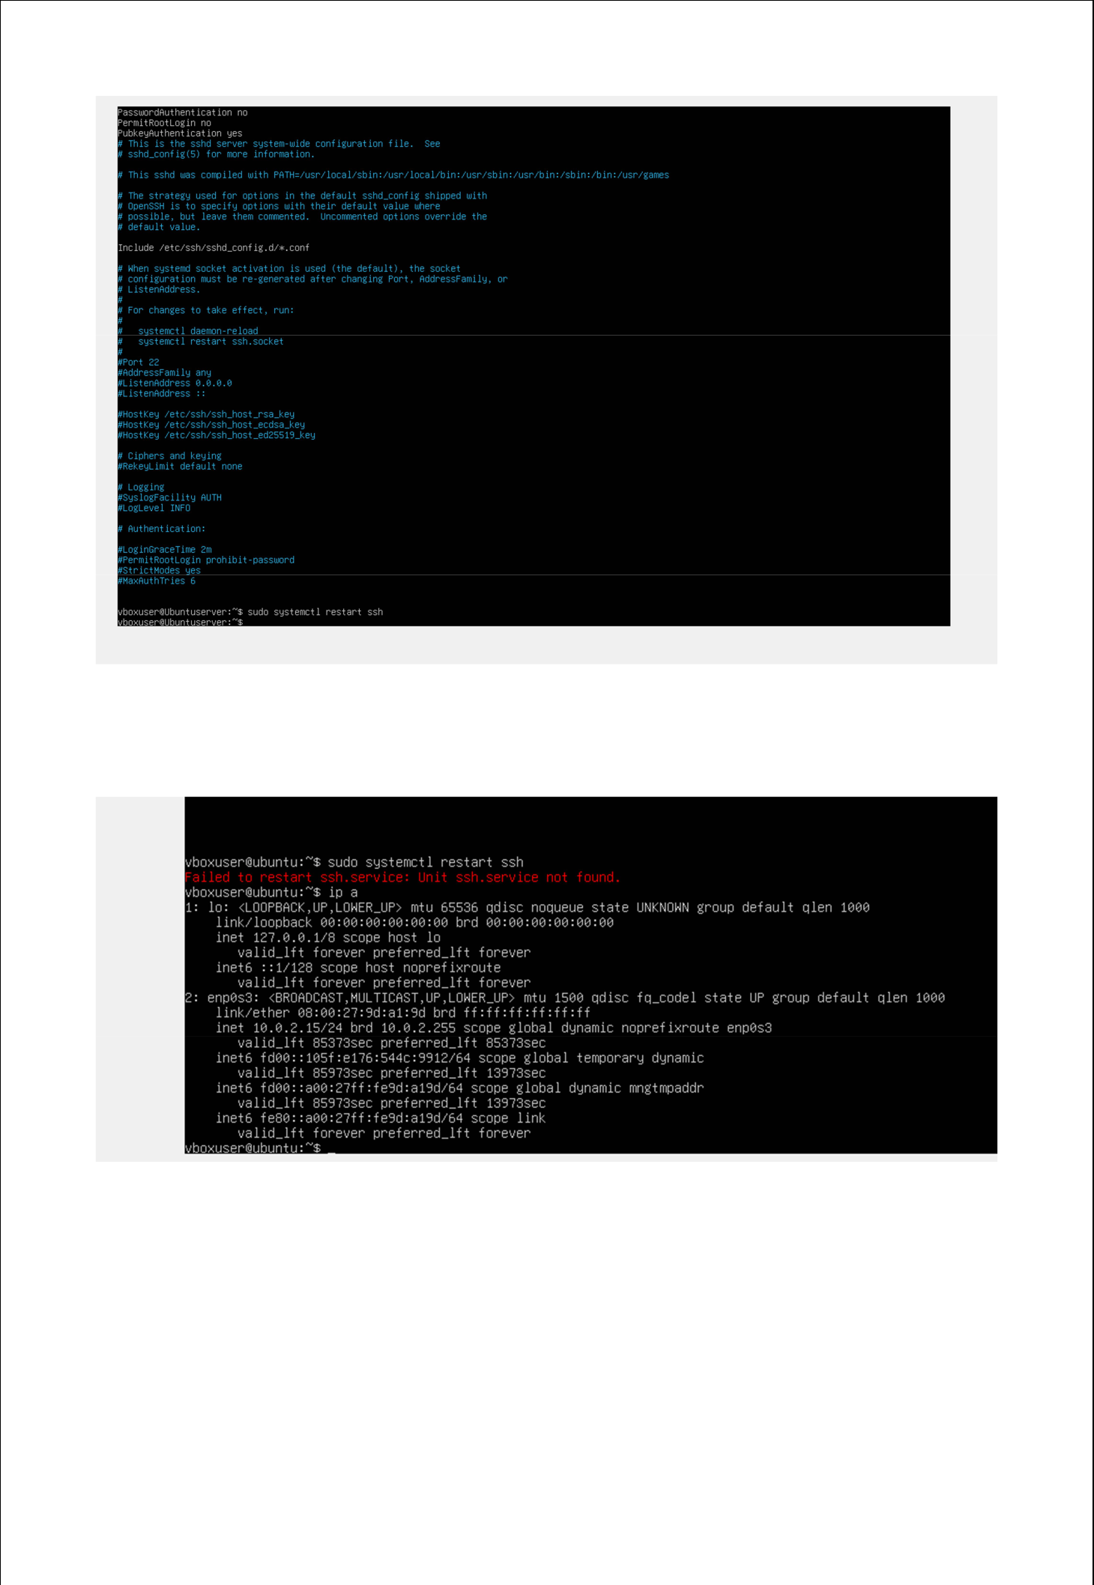

Firewall Configura on and SSH Evidence:
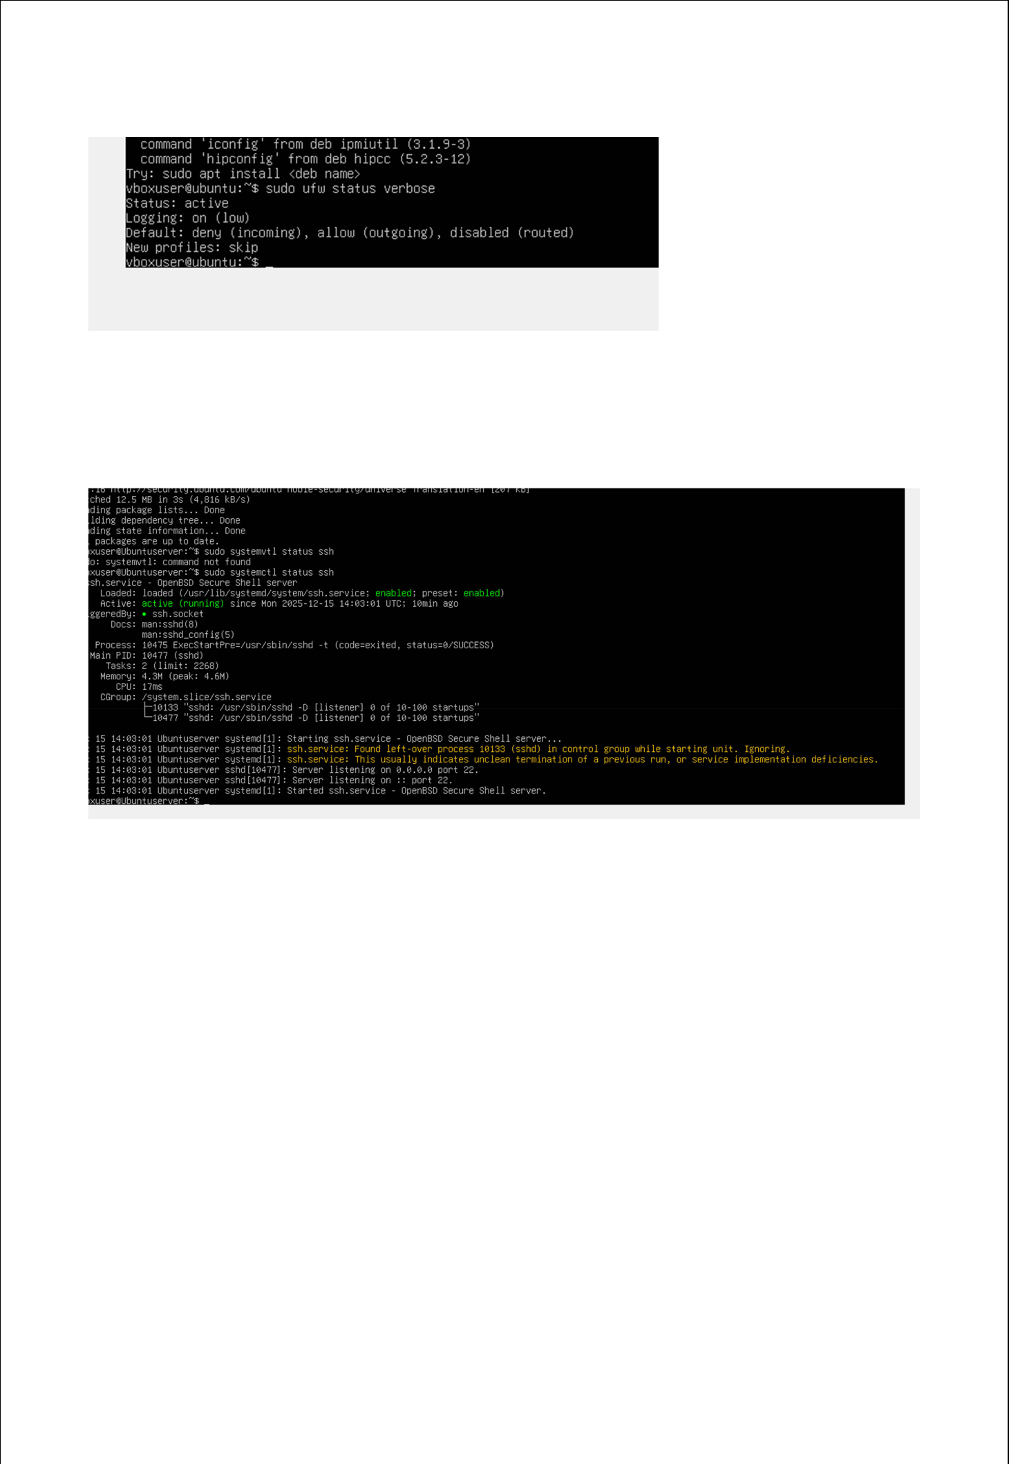
Verbose status:

